Retelling planner: Going swimming
Cut along the dotted line and join the sections together.
Title: Going swimming
Author: Abbey
Beginning — Who and when? | What happened next?
  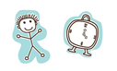 | 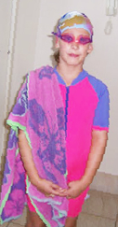
  I went to the swimming pool on Monday
  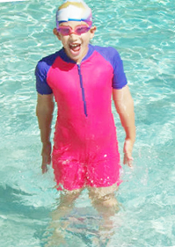
  First, I jumped up and down in the water.
What happened next? | What happened next?
  Next, I went diving for rings. | 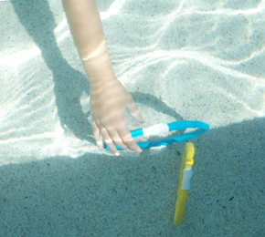
  Then, I swam on my back.
  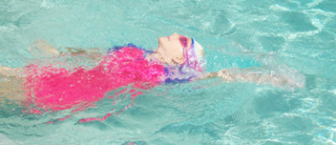
What happened next? | What happened at the end?
  Finally, I swam across the pool. | 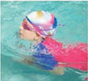
  I like going swimming. | 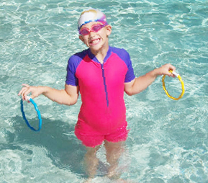
   | 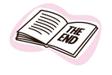
Persons appearing do so with consent.

