This is the way we...
What to do:
- Sing/say the song.
- Add verses about activities completed during the day.
- Sing the verses in order (from morning to night).
Examples of verses
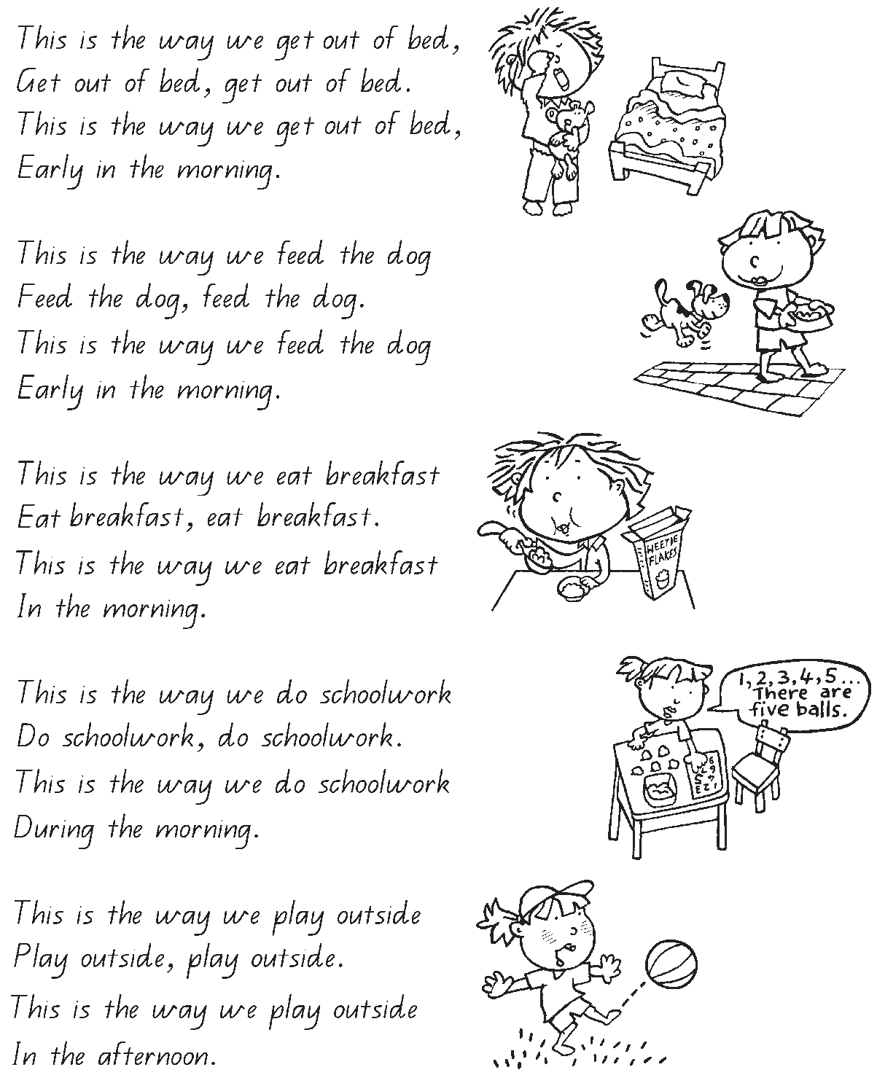

Some other possible verses


