How entertaining is your storytelling?
(Write your name or your friend’s name here)
speaks loudly enough
makes voice interesting 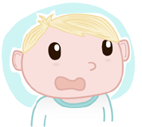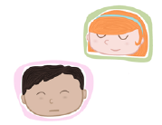
uses describing words

lovely
enormous
orange
happy
uses interesting words from the story
in the quiet dark forest

tells the story in the right order
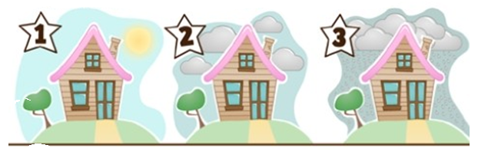
uses other props
