Story map: The hare and the tortoise
1 Read the tortoise’s story events, outlined on the story map on the following page.
2 Cut out the hare’s story events from below and sequence them.
3 Paste the events onto the story map.
4 Retell the fable as you move the hare and tortoise pictures around the story map.
Hare zipped up the hill | 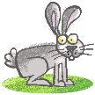
Hare raced to the hedge and stopped to eat.
Hare zoomed to the carrot patch and stopped to eat and sleep. | 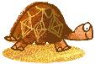
Hare lost the race.

