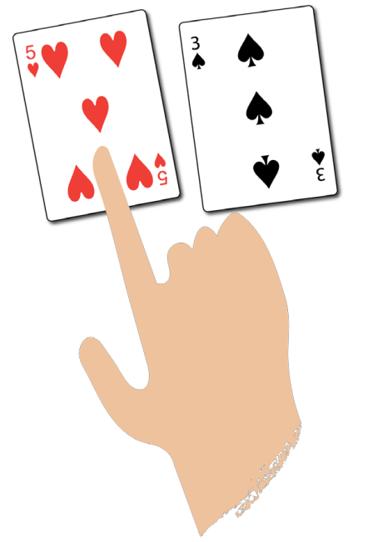
‘Sharing’ card games

Highest number wins

You need:
2 or 3 players
‘Five is
higher than
three.’

A pack of playing cards – remove the jacks, queens and kings
How to play:
- Deal the cards equally to each player. Players put their cards face down
in a pile.
- Each player flips over the top card in their pile.
- The player with the highest number takes all the cards that have been flipped over
and puts them in a separate pile.
- If the numbers are the same, put the cards to one side. On the next round, the player with
the highest number takes those cards too.
- Play until all the cards in each player’s initial pile are used up. The player with the most
cards wins.
Harder: Each player flips over two cards and adds them together. He player with the
highest total takes the cards played.

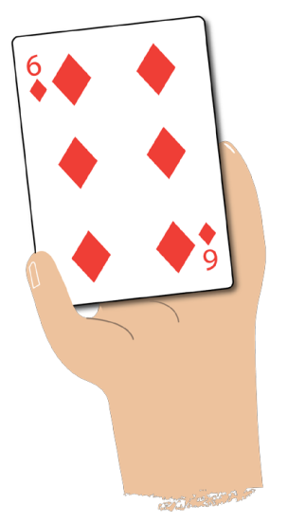

Highest number wins

You need:
2 or 3 players
‘Do you
have a ...?’

A pack of playing cards – remove the jacks, queens and kings
How to play:
- Deal five cards to each player.
- Place the remaining cards in a pile face down.
- If players have two cards that make 10 (e.g. a 6 and a 4), put them down and pick up two
more cards.
- Players take it in turns to ask another player if they have a card that will go with one of their
cards to make ten (e.g. if a player has a 6 in their hand they will ask, ‘Do you have a 4?’)
- If players get the card they need, they put the cards down and pick up two more cards.
- Play until the all the cards in the pile are used up.
- The player with the most pairs wins.
Easier: Use number cards to 5 only.

